Troy Stefano

February 1, 2022

Introduction to data science

Dr. Forouraghi

Assignment 1

**Problem 1:**

For this problem we take chicken feed data from 6 different feeds. They are horsebean, linseed, soybean, sunflower, meatmeal, and casein. With this information I was tasked to find the feed with the best growth output on the chickens. I did this by calculating the min, max, and mean weight of all the feeds. This is what I found.

|  | Min | Mean | Max |
| --- | --- | --- | --- |
| horsebean | 108 | 160.20 | 227 |
| linseed | 141 | 218.75 | 309 |
| soybean | 158 | 246.43 | 329 |
| sunflower | 226 | 328.92 | 423 |
| meatmeal | 153 | 276.91 | 380 |
| casein | 216 | 323.58 | 404 |

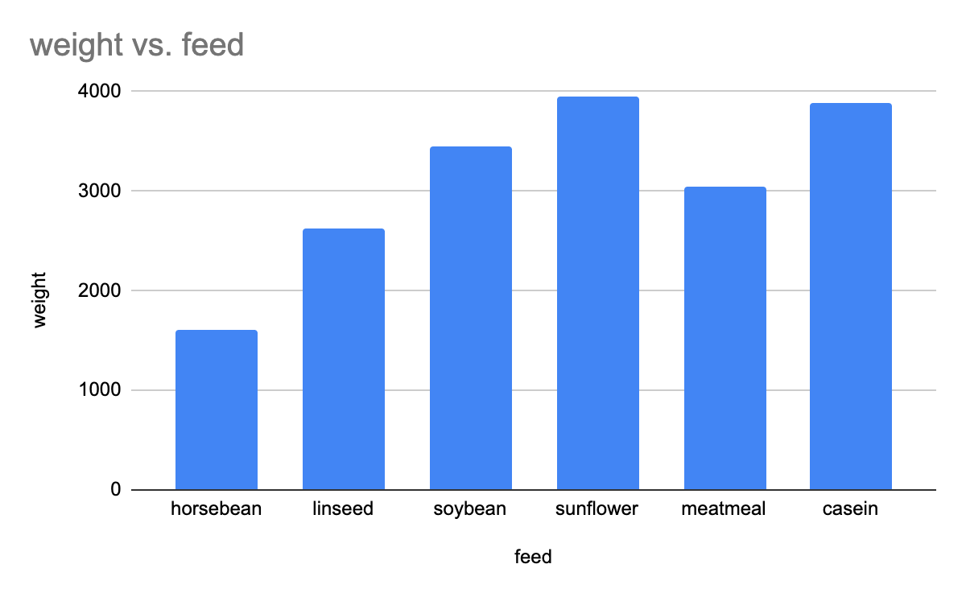

In conclusion I have found that sunflower is the best feed for chickens due to the fact that it produced the highest max weight and it has the largest mean weight.

**Problem 2:**

For this problem I was given 3 different insurance companies and user reviews. These companies are GIECO, Progressive, and USAA. With this data I was tasked to find the best insurance company based upon the user reviews. This is what I found.

| # | insurance provider | Rating (out of 10) |
| --- | --- | --- |
| 1 | GEICO | 4.7 |
| 2 | GEICO | 8.3 |
| 3 | GEICO | 9.2 |
| 4 | Progressive | 7.4 |
| 5 | Progressive | 6.7 |
| 6 | Progressive | 8.9 |
| 7 | USAA | 3.8 |
| 8 | USAA | 6.3 |
| 9 | USAA | 8.1 |

|  | AVG | Sum | Max | Min |
| --- | --- | --- | --- | --- |
| GEICO | 7.4 | 22.2 | 9.2 | 4.7 |
| Progressive | 7.666666667 | 23 | 8.9 | 6.7 |
| USAA | 6.066666667 | 18.2 | 8.1 | 3.8 |

The answer in this data set is more complicated than the data set in the first problem. If one was simply going by mean experience then they would select progressive, but GEICO has the highest rated review. It can also be argued that the 4.7 rating that GEICO received is an outlier, therefore I would select GEICO as my new insurance provider because of their 2 very high reviews.